As a part of pre-migration please follow the below steps:
- Check Orphan Logins at the source server and fix them. Use below script to fix the Orphan logins.
RevLoginScript.txt
- Execute the RevLogin script to script out all the logins. Revlogin script retains the SIDs for the logins and users.
Revlogin Script. Executing Revlogin script will create stored procedure
EXEC sp_help_revlogin to Execute the stored procedure
Segregate the output in three forms
a. Windows Users (starting with Sunwing\username) (Create separate request to create AAD groups for Scoe/SysAdmin Team and add users to those groups) Eg: Please follow the below request
https://sunwing.freshservice.com/a/tickets/137484?current_tab=details
Example:
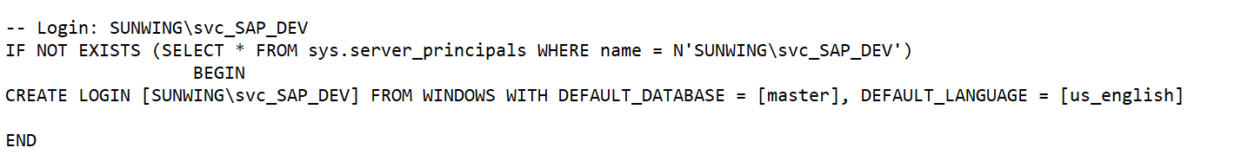
b. SQL Users (They will have passwords in the create script)
Eg:
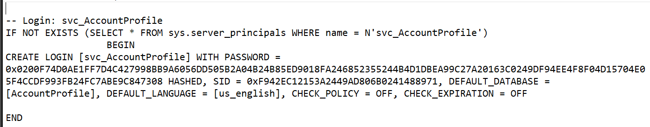
c. AD Groups
Eg:
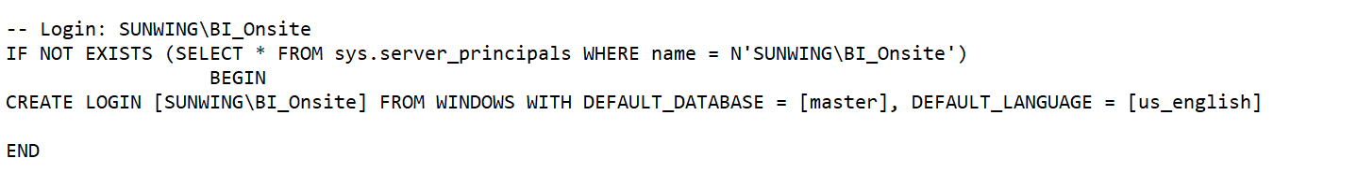
- Replay the script of AD users and SQL users on the target Azure Managed instance and for Windows users, add the login with the help of below script and then map user into respective database.
Create login <Azure AD/Entra Group Name> from EXTERNAL PROVIDER
Create user <user_name> for login <login_name>
- Use the below script to script out the permissions for the database. This will script out the Roles and Object level permissions as well. This stored procedure must be run in context of the database.
Sp_get_object_permissions.txt
Change setting to “Result to Text” (easy to copy) before we execute the SP
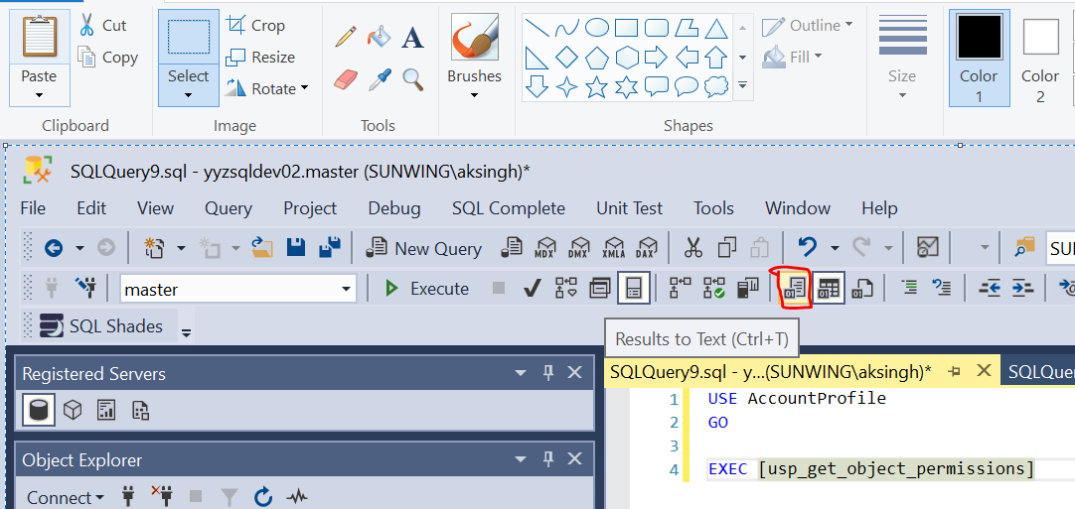
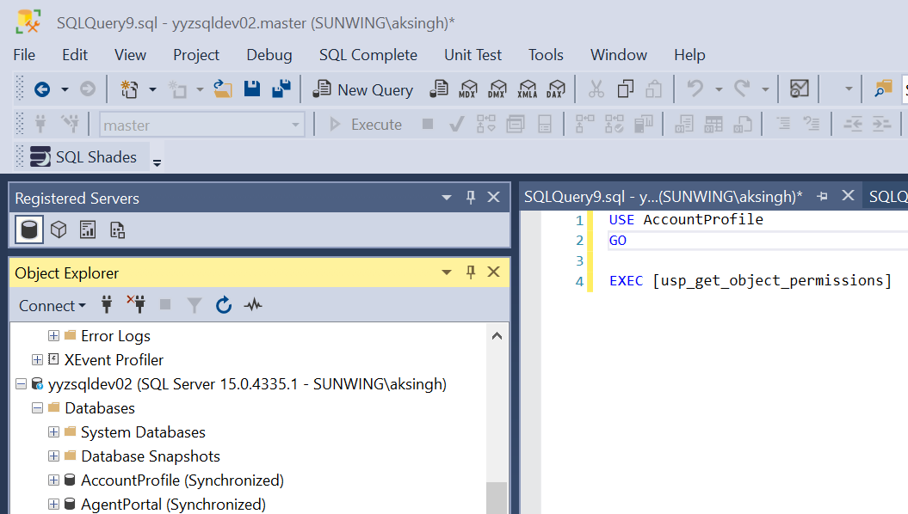
- Migrate the linked servers and make sure to choose MSOLEDB provider while running ‘create-script’ scripted from on-prem SQL Server on Managed Instance. Provider ‘SQLNCLI’ has been deprecated.
Once Linked Server has been created on the Managed Instance, right click, and check the connectivity status.
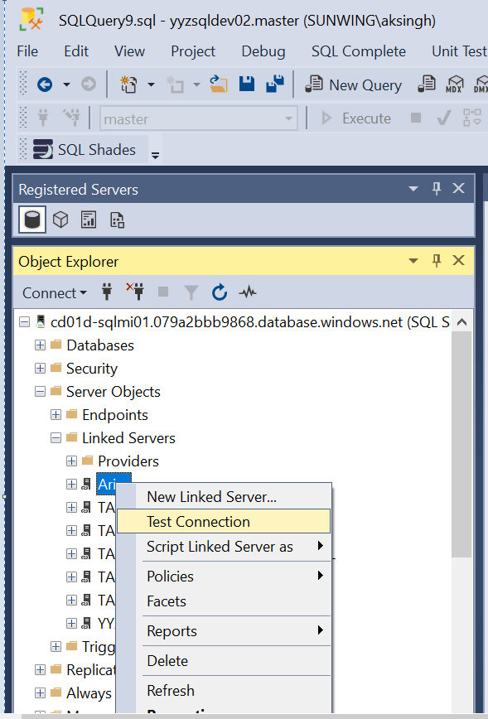
- Upon failure or timeout issues, please create a firewall request as follows.
https://sunwing.freshservice.com/a/tickets/137223?current_tab=details
- Check all the source endpoints and make sure to create firewall requests (make sure to include necessary where conditions in the below query )
Also, look for endpoints such as
SELECT RTRIM( UPPER([Target]) ) AS [Target Endpoint],
RTRIM( [DBname] ) AS [Database Name],
RTRIM( [Source] ) AS [Source Endpoint],
RTRIM( [LoginInfo] ) AS [SQL Login],
RTRIM( [Program] ) AS [Program],
MAX( [LoginTime] ) AS [Last Login Time]
FROM [DBA_Admin].[dbo].[Audit_Login]
WHERE [Program] NOT LIKE '%Microsoft SQL Server Management Studio%' -- End User Software
AND [Source] != @@SERVERNAME -- Local Machine
AND [Source] NOT LIKE 'STG%' -- End User
AND [Source] NOT LIKE 'DB%' -- End User
AND [Source] NOT LIKE 'NBC%' -- End User
AND [Source] NOT LIKE 'DESKTOP%' -- End User
AND [Source] NOT LIKE 'LAPTOP%' -- End User
AND [Source] NOT LIKE 'SOFIFY%' -- End User
AND [Source] NOT LIKE 'SOFTIFY%' -- End User
AND [LoginInfo] != 'DPA' -- Exclude Database Performance Analyzer
AND [LoginInfo] != 'svc_SoftvoyageRep' -- Exclude Softvoyage Replication
AND [LoginInfo] != '' AND [LoginInfo] IS NOT NULL -- Remove empty login names
AND [LoginTime] >= '2022-01-01' -- Only connections for 2023
AND [LoginInfo] NOT LIKE '%SUNWING\%'
AND [Source] NOT LIKE 'dw%'
AND [Source] NOT LIKE 'SWG_%'
AND [LoginInfo] <> 'svc_Capri'
GROUP BY [Target], [DBname], [Source], [LoginInfo], [Program]
ORDER BY [Last Login Time] DESC, [Target], [DBname], [Source], [LoginInfo], [Program]
GO
- We need to ask Ahmed to give read permissions to SQL MI instance so that it could query the Microsoft Entra IDs (to avoid the "Server Identity could not read the Azure AD :Reader Permissions" error)

From this point the document covers the details needed to complete the migration of SQL databases from On-Prem to Azure Managed Instances through Azure Managed Instance Link feature.
We attempted the migration from YYZSQLDEV01/02 to Azure Managed Instance cd01d-sqlmi01.079a2bbb9868.database.windows.net
Source : YYZSQLDEV01/02
Target : cd01d-sqlmi01.079a2bbb9868.database.windows.net
Phase1: Testing connectivity
Verify the connectivity from on-prem SQL Server to Azure Managed Instance:
Need to test the connectivity between source and destination and this is important for setting up the Azure Managed Instance Link.
- Execute the below queries to test connectivity from SQL Server to Managed Instance.
The 1st query needs to be executed on Managed Instance to generate the parameters.
1_Run_this_script_on_SQL_MI_to_generate_parameters.sql
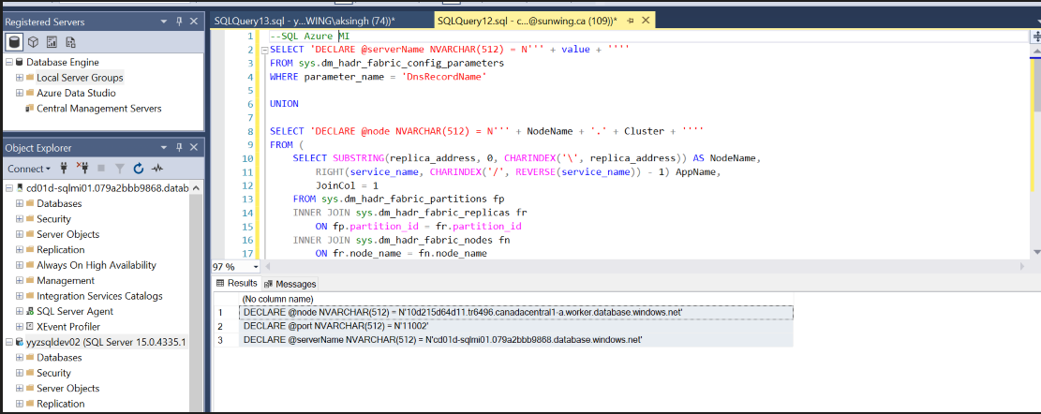
2_Run_thisScript_on_SQLServer_with_Parameters_from_the_Prev_Script.sql
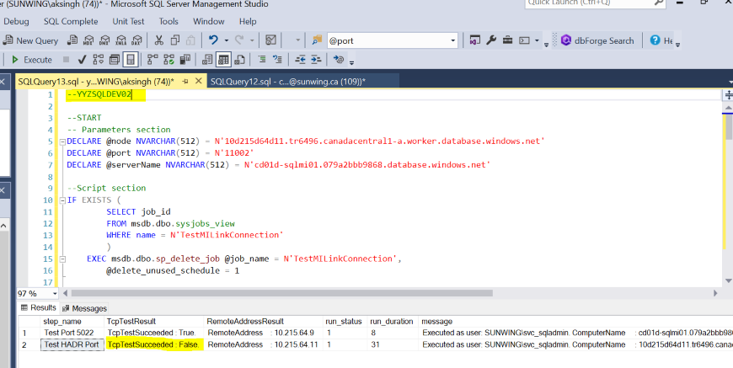
Parameters generated in the 1st query need to be used in the below variables and executed on the On-Prem server
DECLARE @node NVARCHAR(512) = N''
DECLARE @port NVARCHAR(512) = N''
DECLARE @serverName NVARCHAR(512) = N''

Observe the ‘TcpTestResult’ column and if the ‘TcpTestSuccessed:True’ then we are good with respect to connectivity from On-Prem to Managed Instance side.

If the response is unsuccessful, verify the following network settings:
- There are rules in both the network firewall and the SQL Server host OS (Windows) firewall that allows traffic to the entire subnet IP range of SQL Managed Instance.

Verify the connectivity from Azure Managed Instance to On-Prem SQL Server:

Make sure to create certificates to test the endpoints
-- Run on SQL Server
-- Create the certificate needed for the test endpoint

-- Run on SQL Server
-- Create a master key
USE master;
GO
CREATE MASTER KEY ENCRYPTION BY PASSWORD = 'StrongPassword';

-- Run on SQL Server
USE master;
GO
SELECT * FROM sys.symmetric_keys WHERE name LIKE '%DatabaseMasterKey%';

USE MASTER
CREATE CERTIFICATE TEST_CERT
WITH SUBJECT = N'Certificate for SQL Server',
EXPIRY_DATE = N'3/30/2051'
GO

-- Create the test endpoint on SQL Server
USE MASTER
CREATE ENDPOINT TEST_ENDPOINT
STATE=STARTED
AS TCP (LISTENER_PORT=5022, LISTENER_IP = ALL)
FOR DATABASE_MIRRORING (
ROLE=ALL,
AUTHENTICATION = CERTIFICATE TEST_CERT,
ENCRYPTION = REQUIRED ALGORITHM AES
)
1. Execute the code in the following attached file ‘1_SQL_MI_JobCreation’ on Azure Managed Instance and supply the IP address of the On-Prem Server in the code as shown below.

1_SQL_MI_JobCreation.sql

- Execute the attached code ‘2_SQL_MI_Create_NetHelper_StoredProc’ on the Azure Managed Instance. This will create a stored procedure with the name ‘NetHelper’.
2_SQL_MI_Create_NetHelper_StoredProc.sql
- Execute the stored procedure on the Managed Instance and observe the output in ‘Connectivity Status’ EXEC ExecuteNetHelper
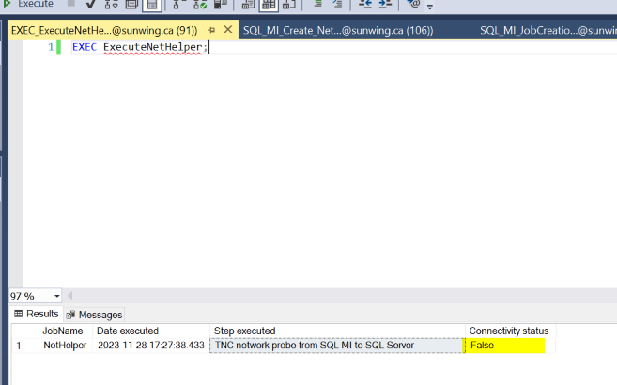
Now, to facilitate the connectivity between On-Prem SQL and Azure Managed Instance we have established Vnet Peering between On-Prem <-----------> Azure Managed Instance.
From: On-Prem SQL------->To: Azure Managed Instance and
From: Azure Managed Instance ------> To: On-Prem
Below is the request we have opened for NetOps Team to establish peering
https://sunwing.freshservice.com/a/tickets/136627?current_tab=details
dev02-acc-vnet-10.212.32.0_20 <---> CD01D-VNET-DB-SQLMI-10.215.64.0_20
qa02-acc-vnet-10.213.32.0_20 <---> CQ01Q-VNET-DB-SQLMI-10.215.144.0_20
uat02-acc-vnet-10.211.32.0_20 <---> CU01U-VNET-DB-SQLMI-10.215.224.0_20
Peering establishes connections between VNets, enabling network traffic to flow through alternative routes. Consequently, this eliminates the necessity to create individual firewall rules for specific ports.
After Peering has been enabled, we have performed the network connectivity tests, and all were succeeded.
On-Prem SQL to Azure Managed Instance
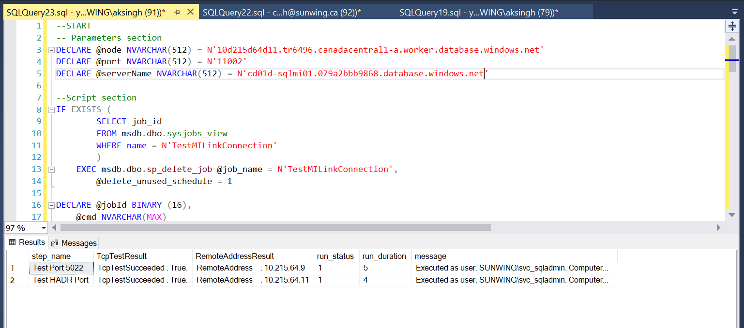
Azure Managed Instance to On-Prem SQL Server
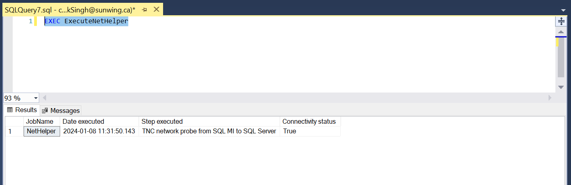
At this point we are good with respect to connectivity.
Phase2: Checking and implementing the pre-requisites from SQL side.
- Azure Managed Instance Link will only work for the below versions of SQL Server and with SSMS 19.2
2016 SP3, 2019, 2022 (Azure Managed Instance link will not work for SQL 2017)
- Always on must be enabled for the SQL Server.
Go to the SQL Server Configuration Manager and enable the Always on option. This would require recycle of SQL Services
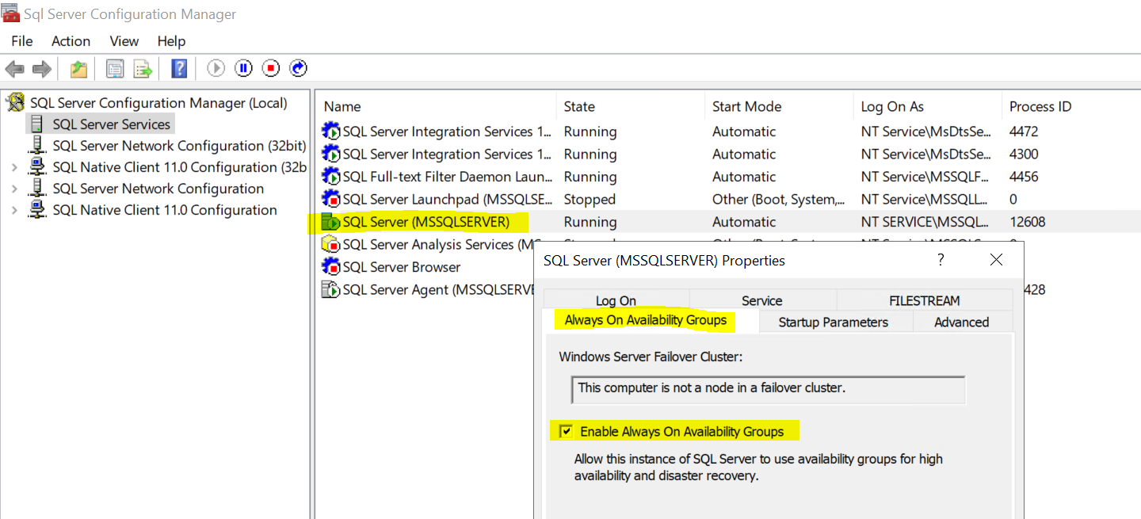
- Enable the trace flags 1800 and 9567
DBCC TRACEON(1800,-1)
DBCC TRACEON(9567,-1)
- Once done, please review all the settings with the below query.
USE master;
GO
SELECT @@VERSION as 'SQL Server version';
GO
-- Shows if the Always On availability groups feature is enabled
SELECT SERVERPROPERTY ('IsHadrEnabled') as 'Is Always On enabled? (1 true, 0 false)';
GO
-- Lists all trace flags enabled on SQL Server
DBCC TRACESTATUS;
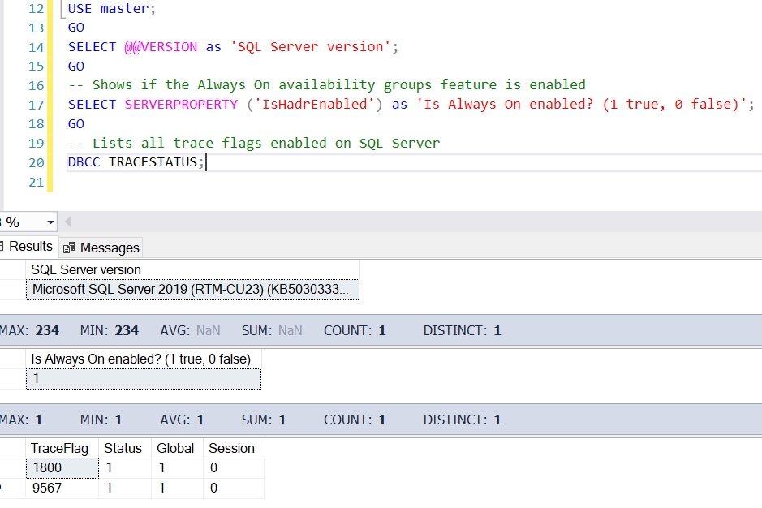
Phase3: Setting up Azure Managed Instance Link feature.
- Changed the database recovery model to FULL and execute a backup of the database before the respective database is added to the Azure Managed Instance Link.
- Also, make sure we have a backup maintenance plan in place at the On-Prem Server to run transaction log backups since in FULL recovery model log files might increase for long running transaction.
- Right click on the database and choose ‘Azure Managed Instance Link’ and select ‘New’
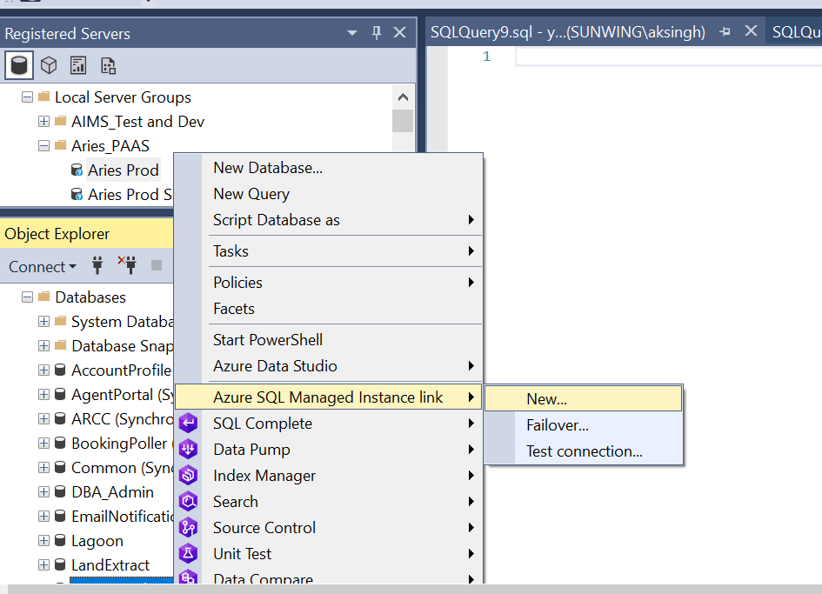
- Next, it will launch the setup for Azure Managed Instance Link
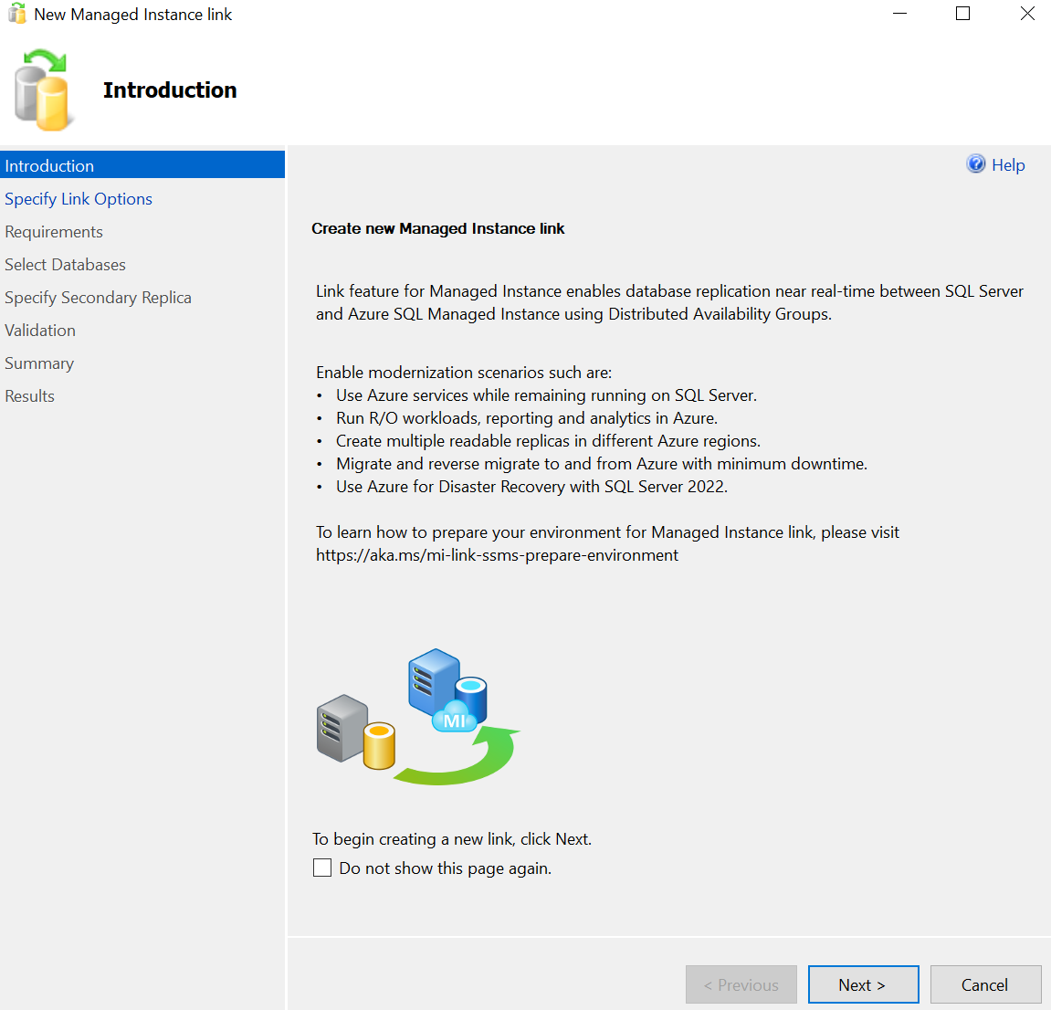
- Input the name of the link as show in the screenshot below and click ‘Next’
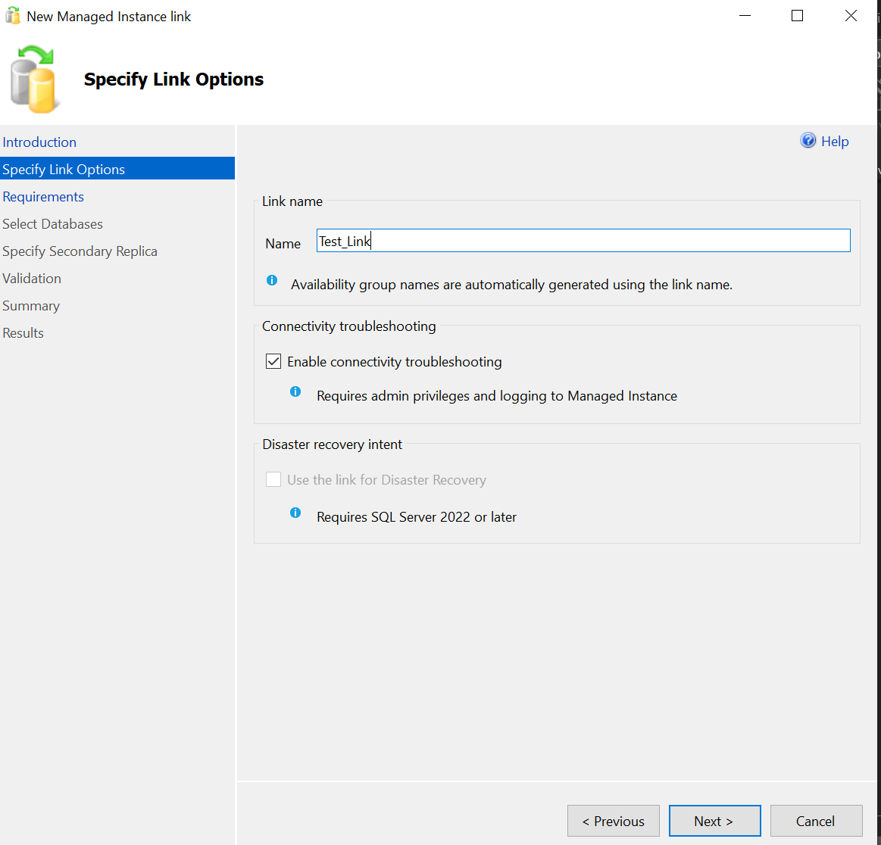
- Next Step will perform the connectivity checks and pre-requisite checks
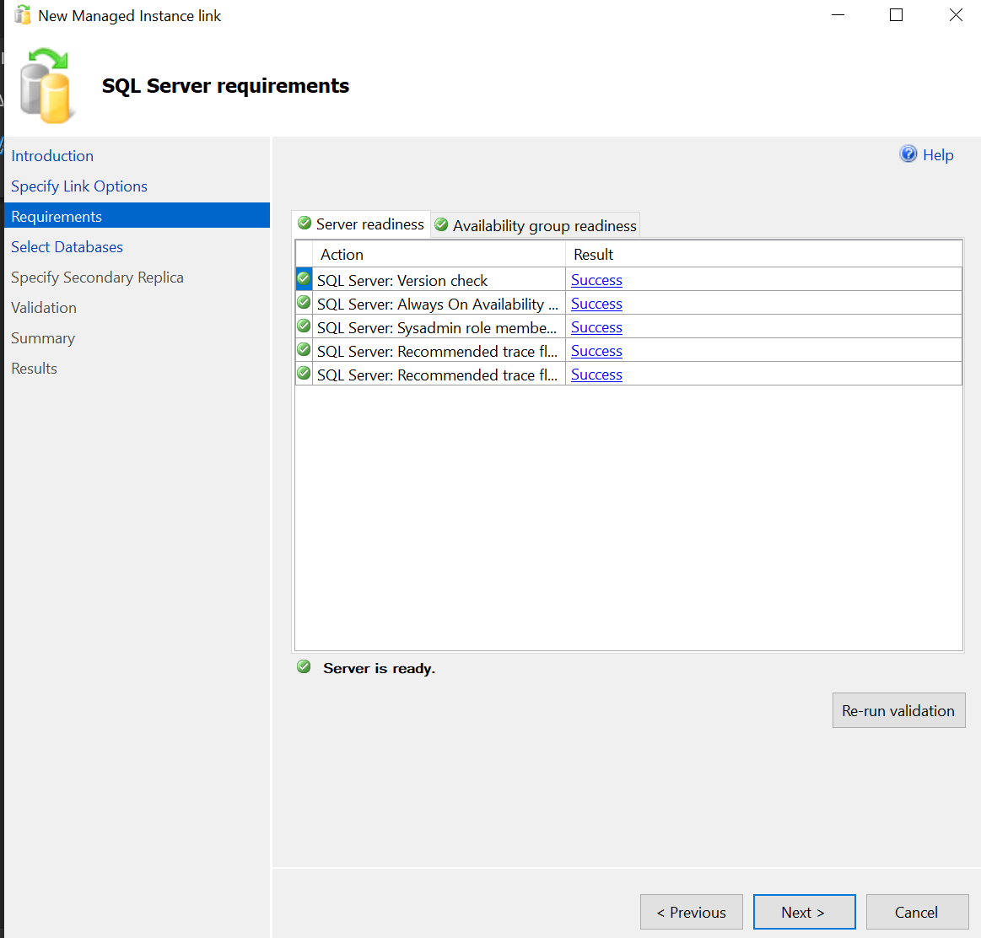
- Select the respective database from the list as shown in the figure. Only one database can be chosen per link. Please do not select multiple databases.
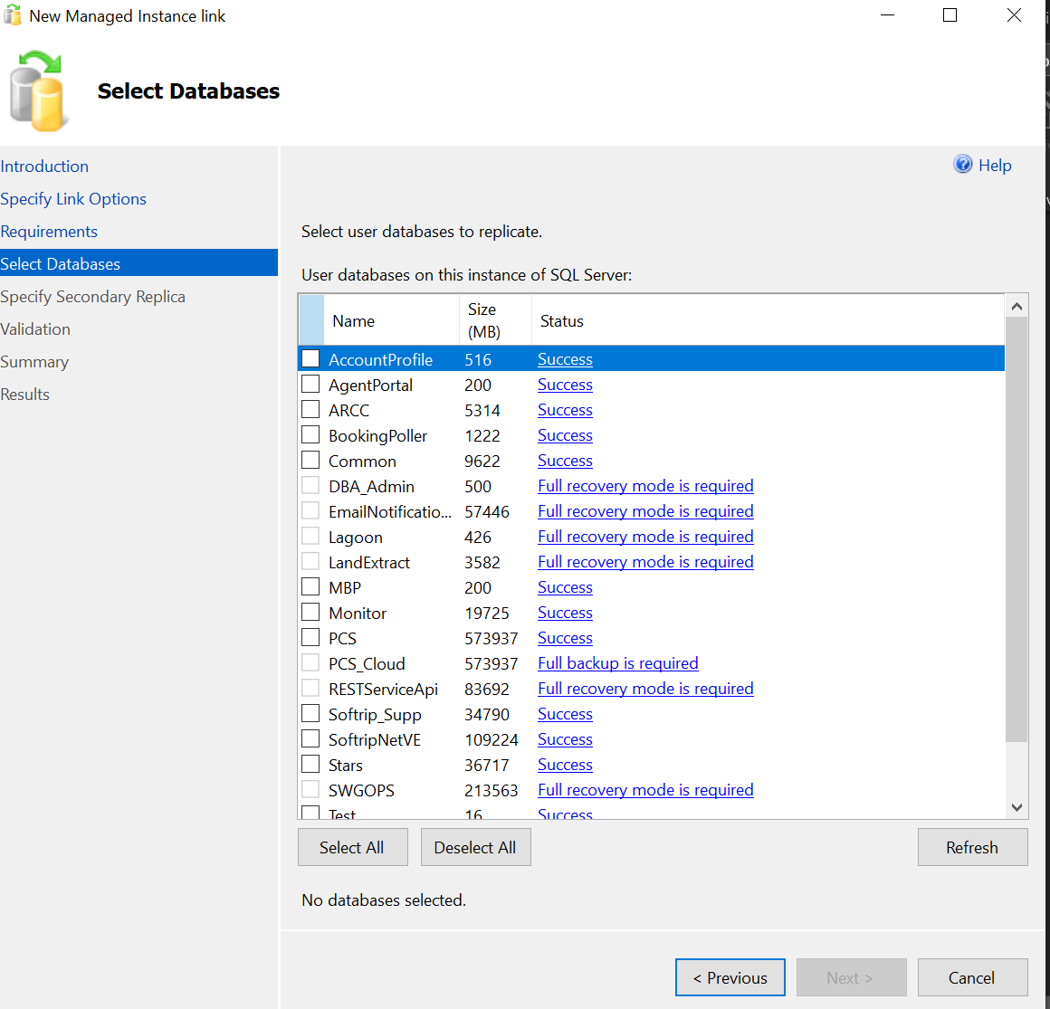
- We need to add/select the replica node which is the MI instance in our case.
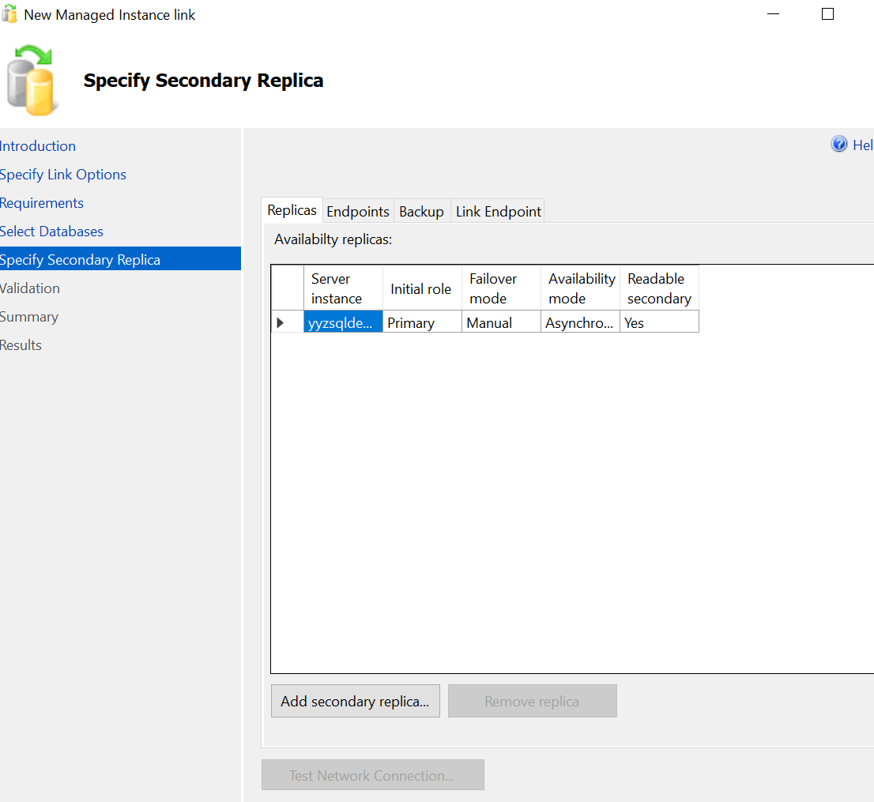
- Click on ‘Add Secondary Replica’ and Sign in
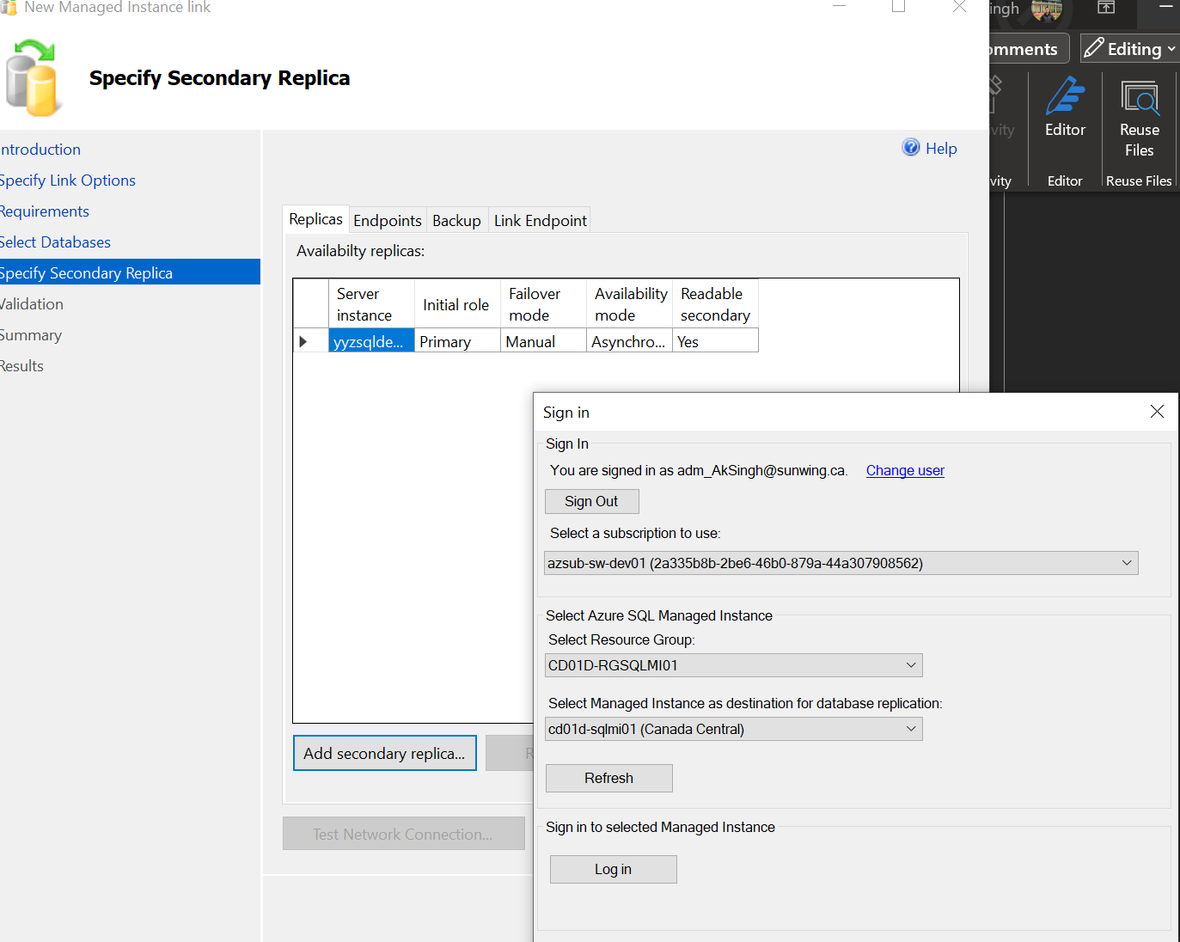
- Managed Instance server name would be added in the setup
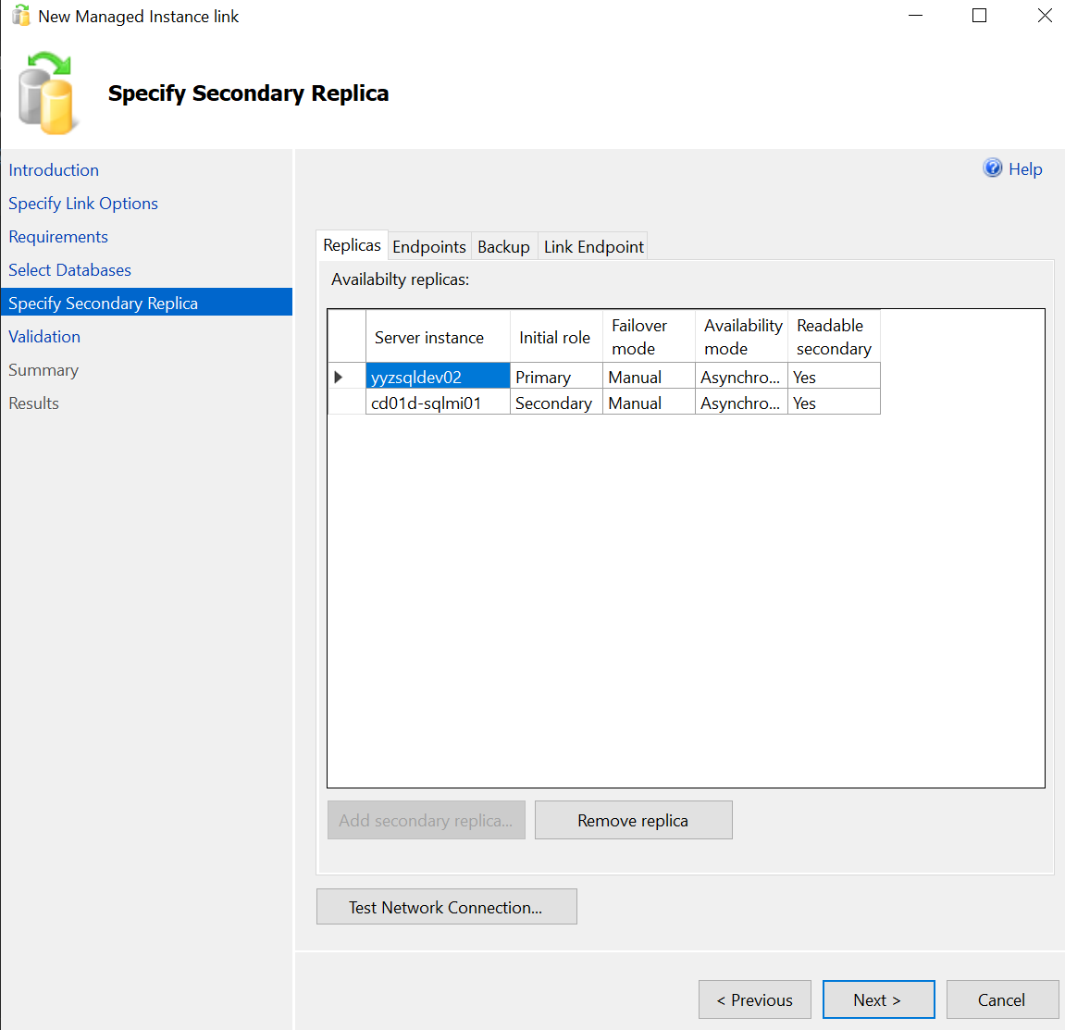
- Setup would validate the given inputs.
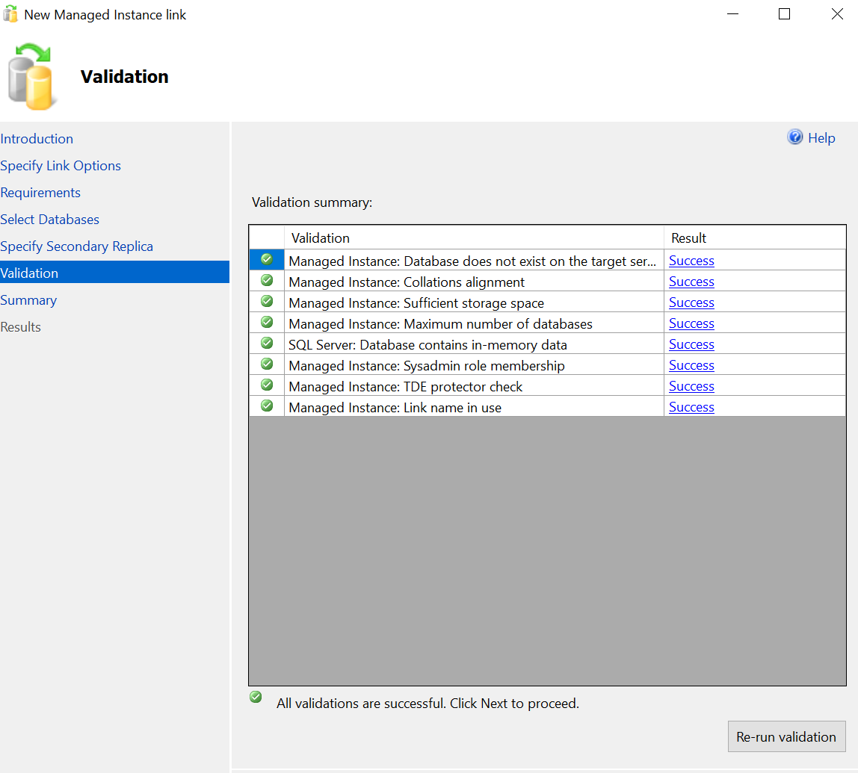
- Click on ‘Finish’ to complete the setup.
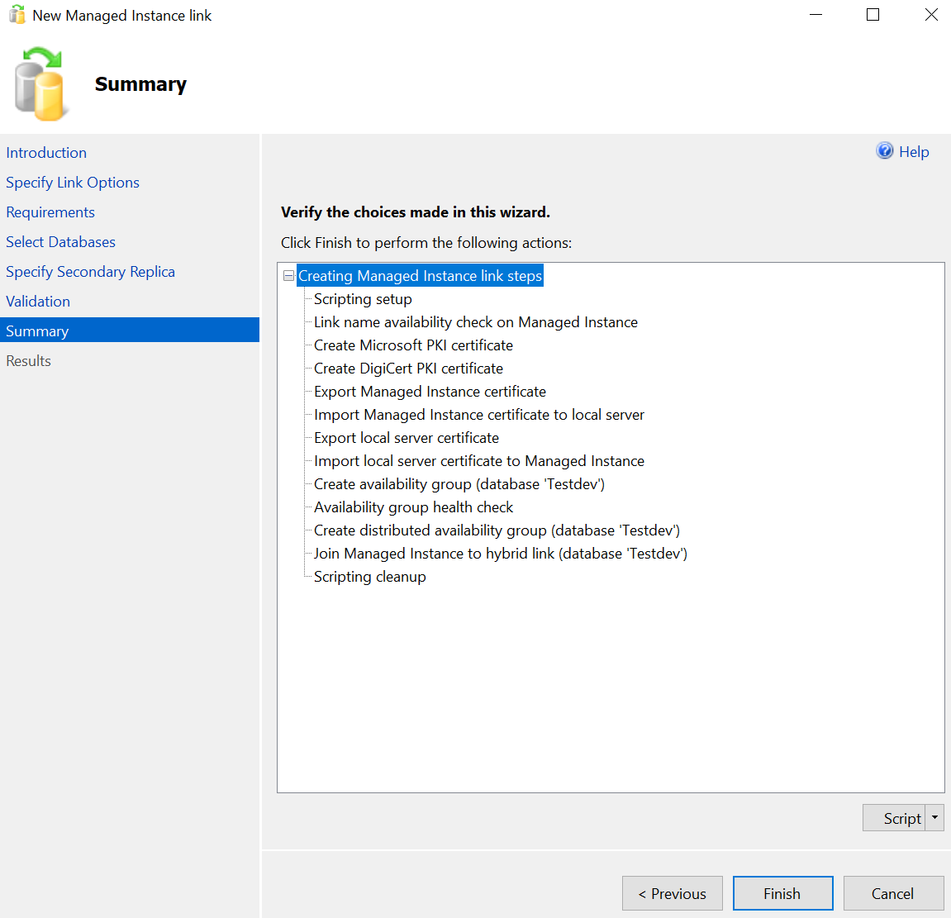
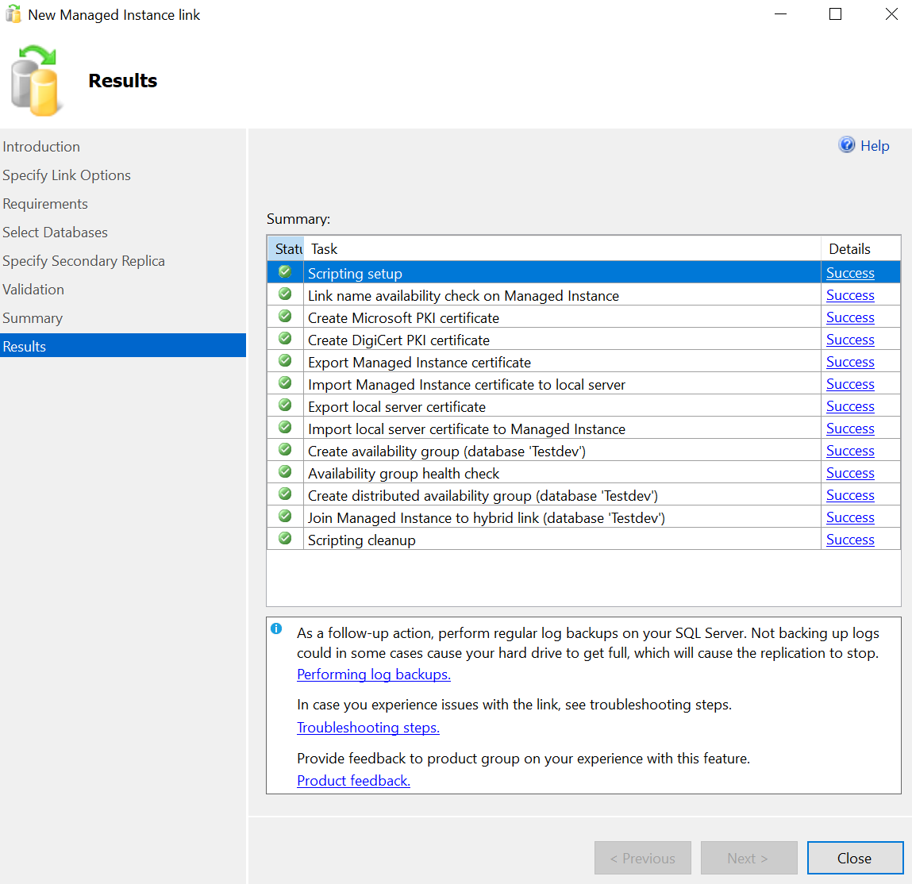
- Databases would appear as ‘Synchronized’ at both the servers
On-Prem SQL Azure Managed Instance
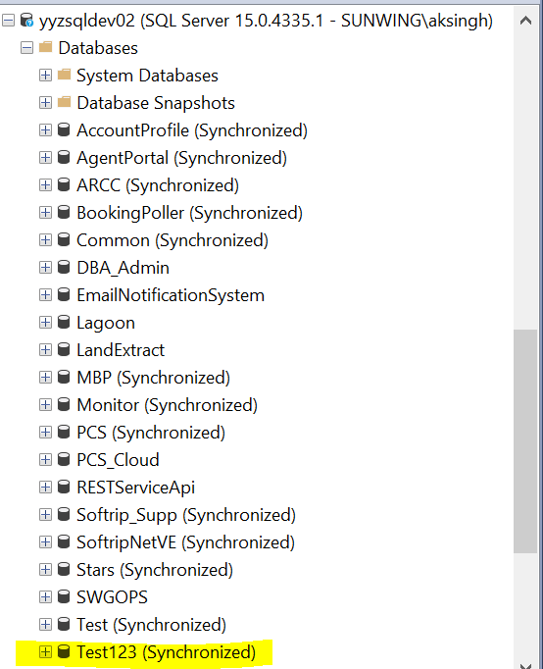 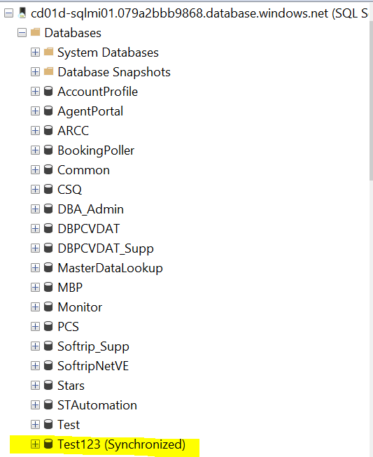

With this the Azure Managed Instance Link setup has been completed and database has been added to it for the purpose of migration. Now, all the changes coming to ‘Test123’ at On-Prem will be propagating to Azure Managed Instance and we can read the database at secondary replica however cannot write to it.

Phase 4: Performing the Cutover (Failover in Azure Managed Instance Link)
Inform the Application Team and we will be performing cutover on specific date and time. When time comes, please follow the below steps for performing the cutover.
- Right click on the database and select Azure Managed Instance link and choose ‘Failover’.
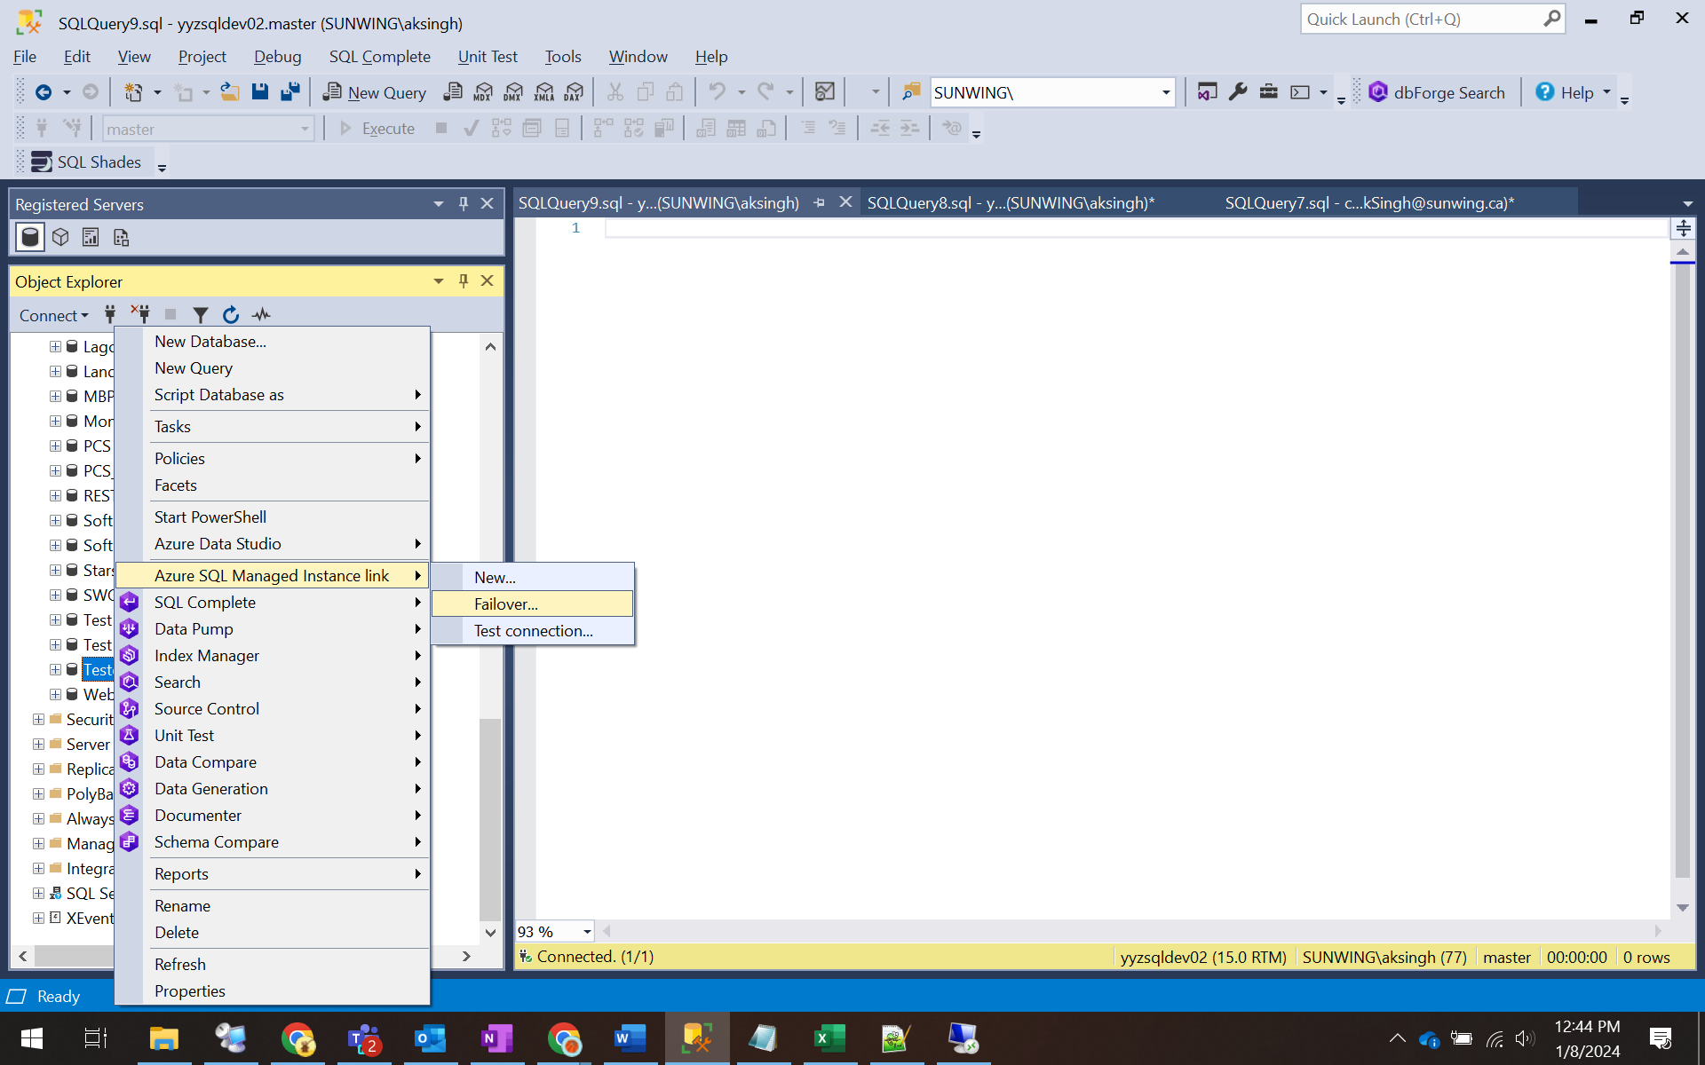
- This will launch the ‘Failover’ setup as follows
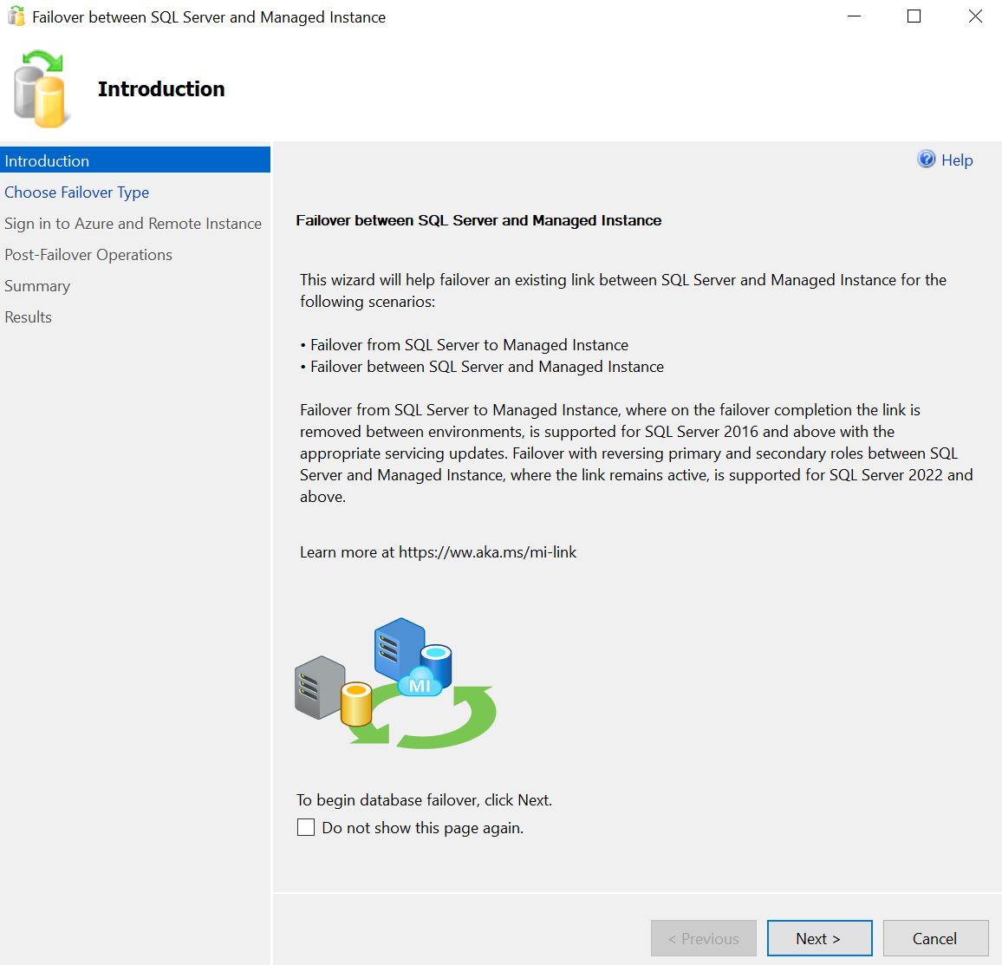
- Select the planned failover (failover type depends on version of SQL Server)
Planner Failover will appear with database compatibility 150 and for databases less than 150 it will be Forced Failover.
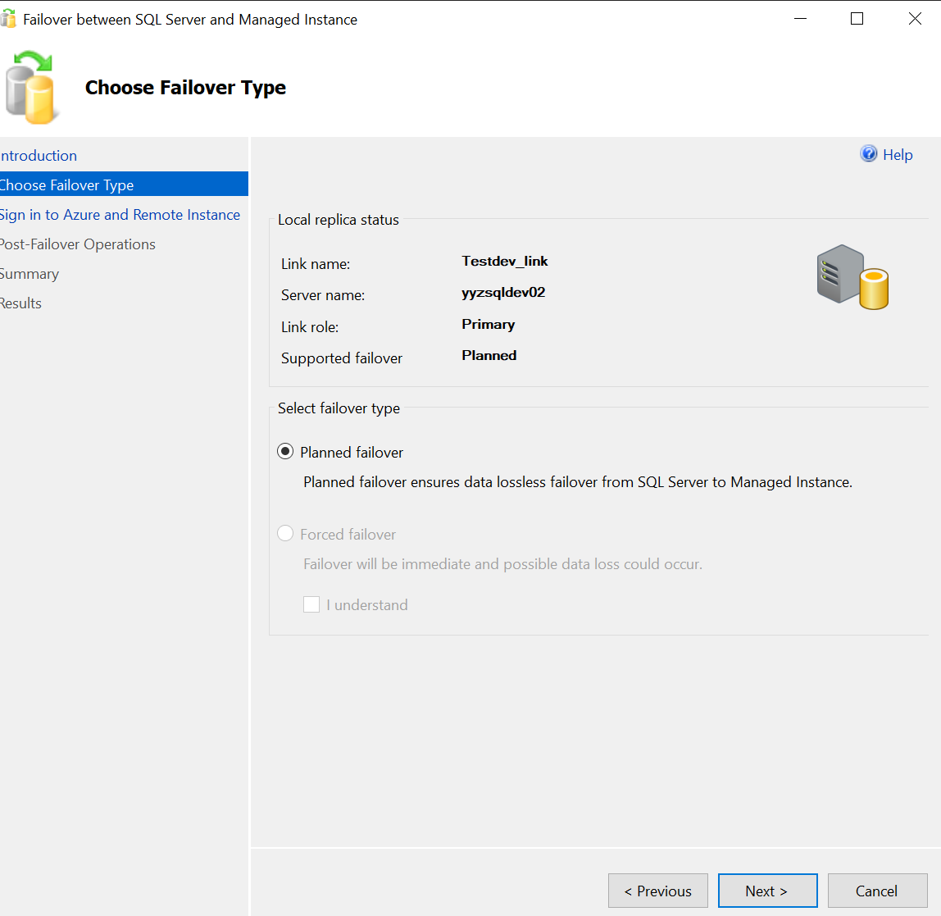
- Sign in and connect to the Azure Managed Instance.
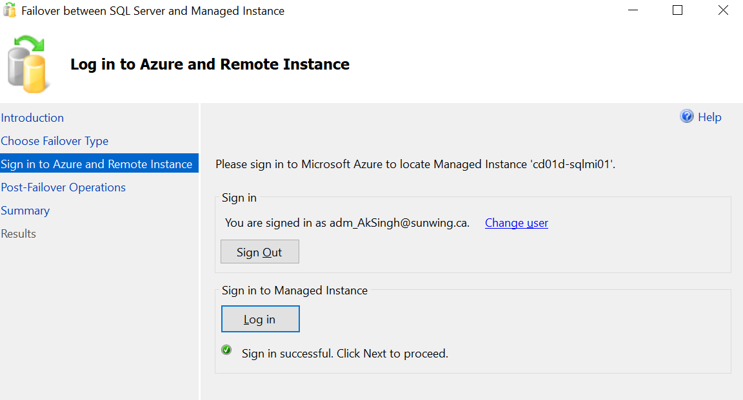
- Give confirmation for the Link removal.
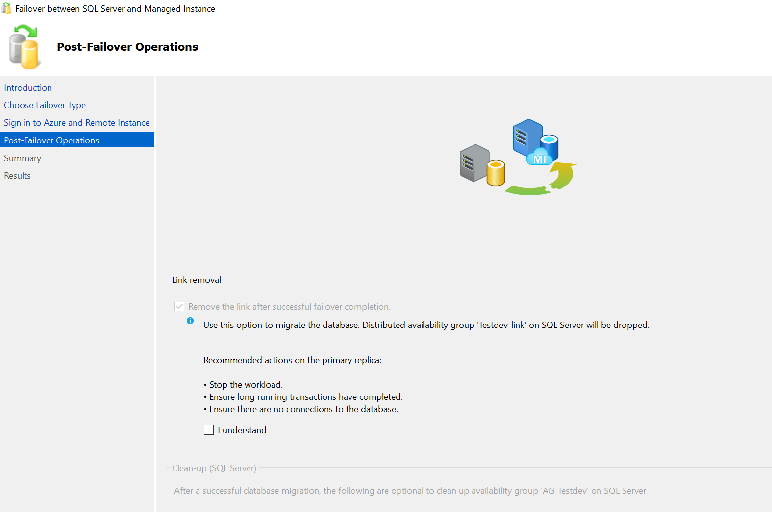
- Click on ‘Finish’ to complete the setup
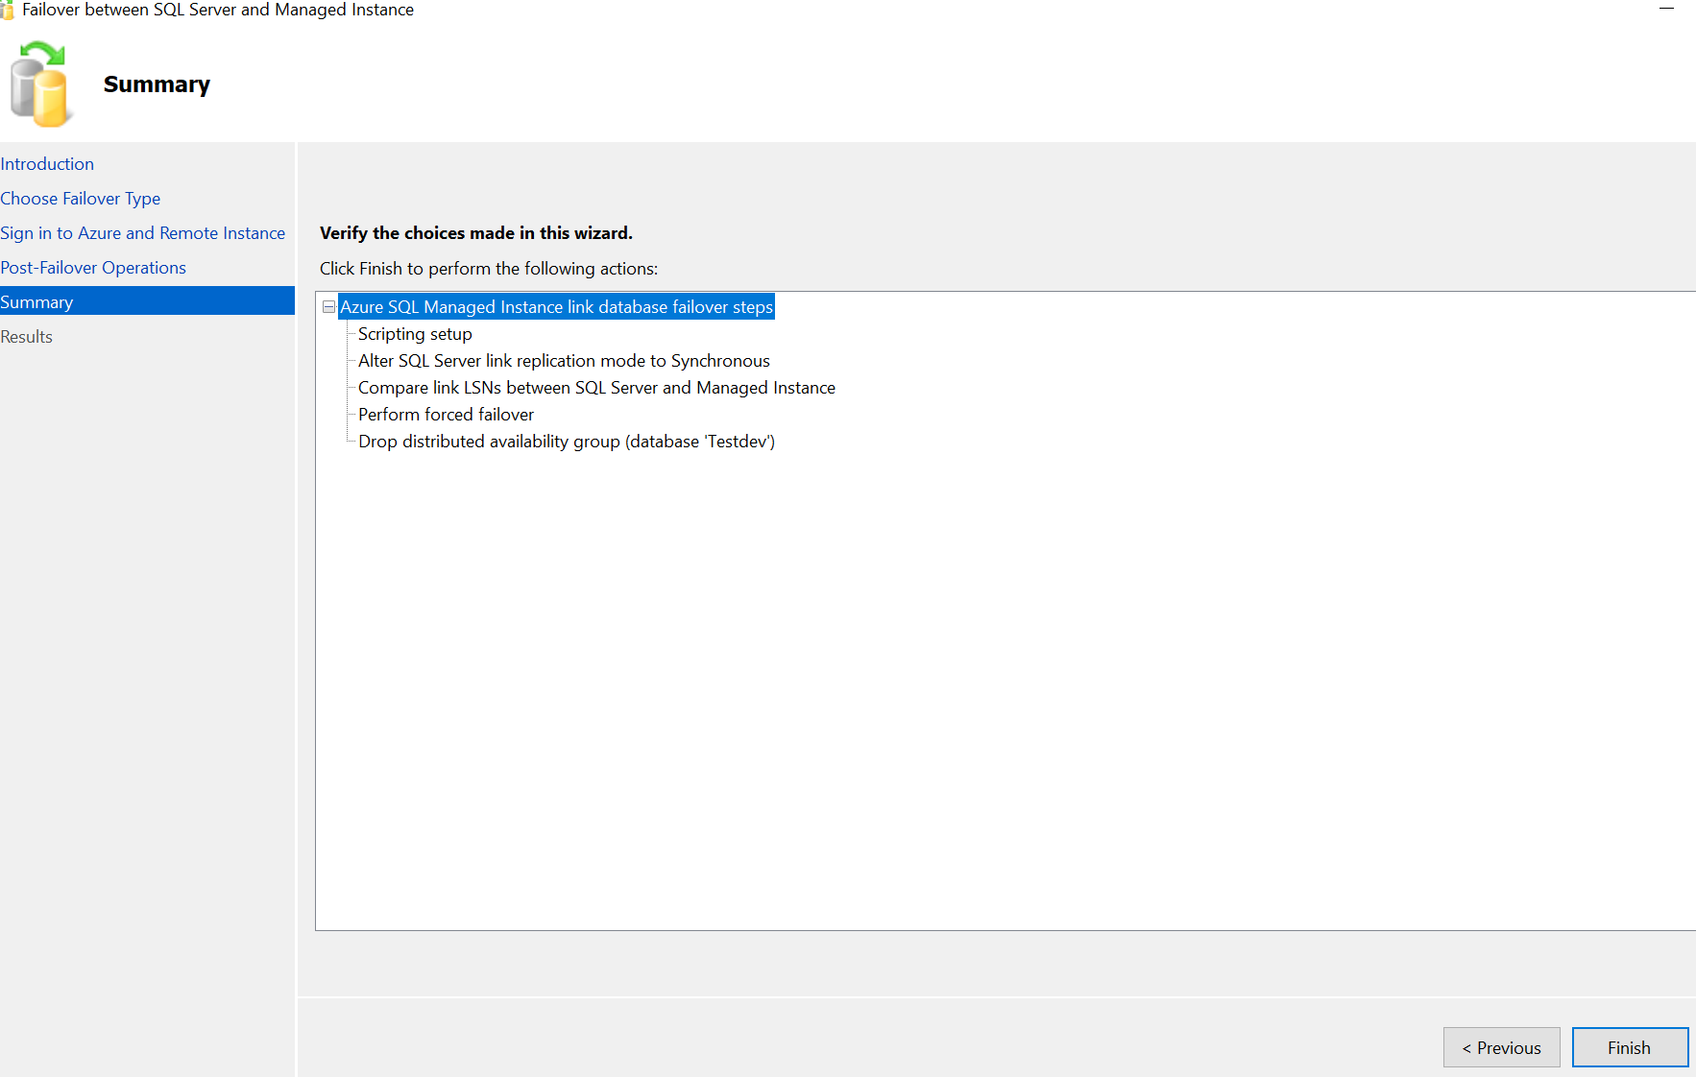
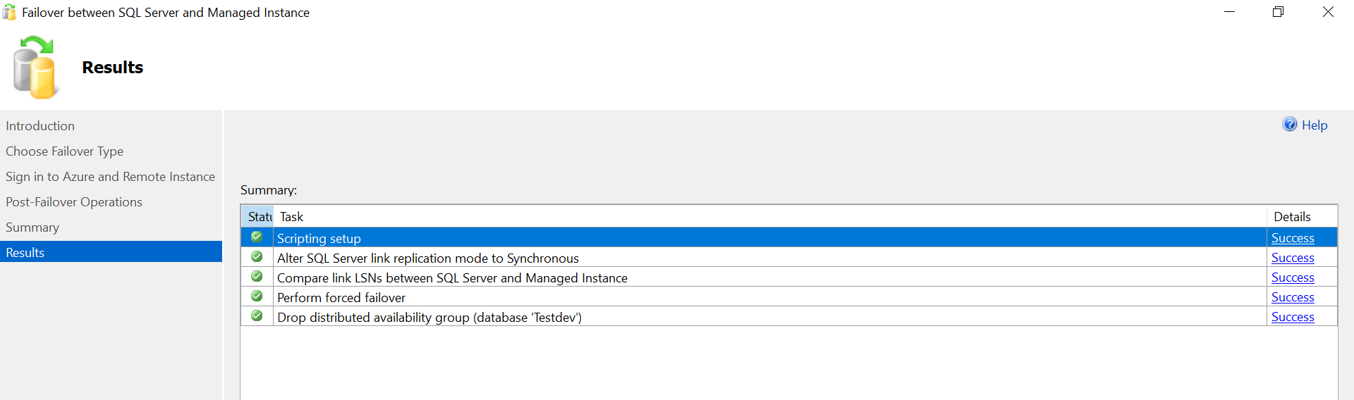

With this the database cutover from the Azure Managed Instance link has been completed.
We must do user and login sync-up and give appropriate rights to the users through the scripts scripted out earlier.
Inform the DEV Leads #IT-Developers, #IT Business Intelligence and of course DBA_Admin that migration has been completed and connections can now be tested and validated.

